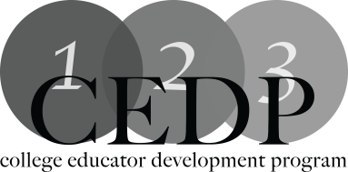

Matching Assessment Methods to Learning Outcomes –Leslie Marshall

Workshop Description:
Are you seeing the level of student performance you expect on your assessment activities? If not, perhaps the solution can be found in integrated course development. This presentation/workshop explores Fink’s (2003) concept of integrated course design and presents ideas and tools to ensure assessment is directly connected to learning outcomes and course activities. Moving assessments from “content-based” to “outcome-based” is a key focus. In the process, participants examine fundamental principles and beliefs about assessment, including the concept of authentic assessment, and how those principles and concepts play into integrated course development.

Learning Outcomes
Outline Integrated Course Design concepts
Utilize ICD in course development

Facilitator: Leslie Marshall
For more information: leslie.marshall@mohawkcollege.ca

Suggested Resources:
Fink & Associates: A Self-Directed Guide to Designing Courses for Significant Learning
http://www.deefinkandassociates.com/GuidetoCourseDesignAug05.pdf
Beckett, D., Volante, L., Drake, S. (n.d.). Formative Assessment: Bridging the Research – Practice Divide. The Canadian Education Association. Retrieved December 12, 2012 from http://www.cea-ace.ca/education-canada/article/formative-assessment-bridging-research-practice-divide
Banta T. W., Lund, J.P., Black, K.E., Oblander, F.W. (1996) Assessment in Practice: Putting Principles to Work on College Campuses. San Francisco: Jossey-Bass.
Fink, D.L. (2003). Creating Significant Learning Experiences: An Integrated Approach to Designing College Courses. San Francisco: Jossey-Bass.
Incorporating and Documenting Effective Assessment. Park University. Retrieved January 11, 2012 from http://www.park.edu/cetl/quicktips/effectiveassess.html
Stiehl, R. and Lewchuk, L. (2008). The Assessment Primer: Creating a Flow of Learning Evidence. Corvallis, Oregon: The Learning Organization.

